1. Write a pig script to find the count of each Hashtag in the dataset. You can download the twitter data from the below link

Here we are supposed to count the number of hashtags in the twitter data given. For this we need to register elephant-bird-hadoop-compat-4.1.jar and elephant-bird-pig-4.1.jar along with the json-simple-1.1.1.jar. As this files are need to get the entire data that is getting from the twitter as the data is in different file so this jars are need to execute the load command to get the entire data.

And to get the count of the hashtags.

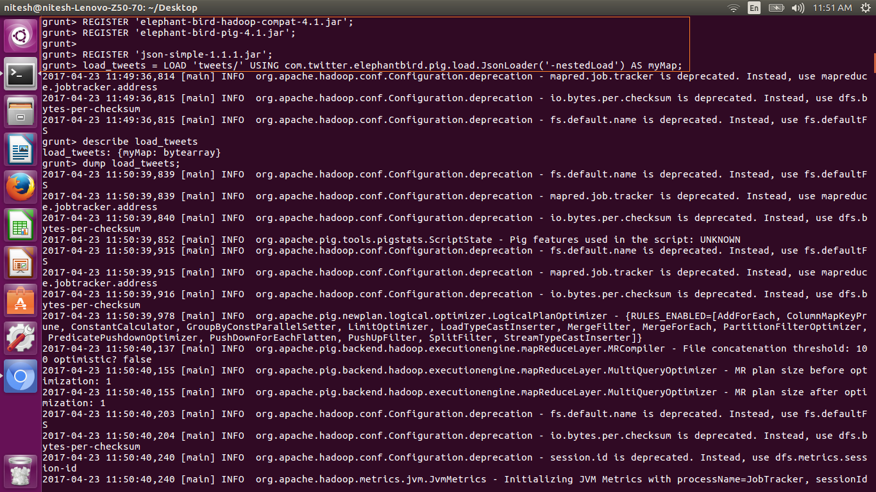

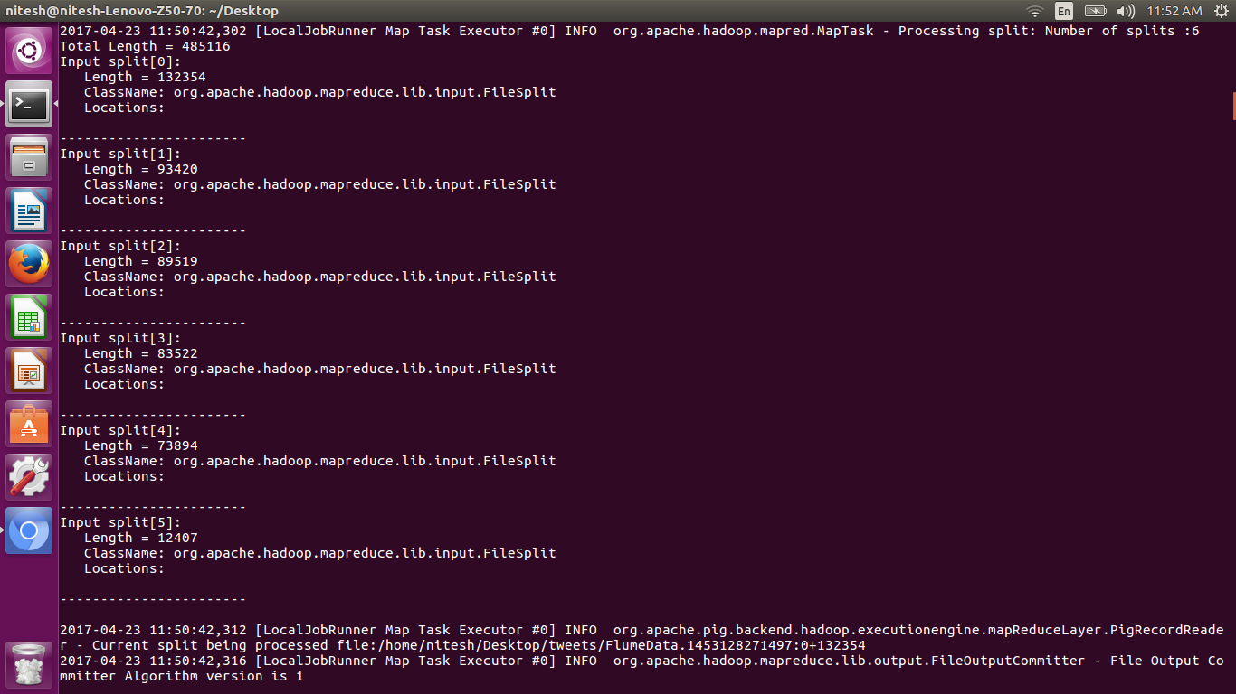

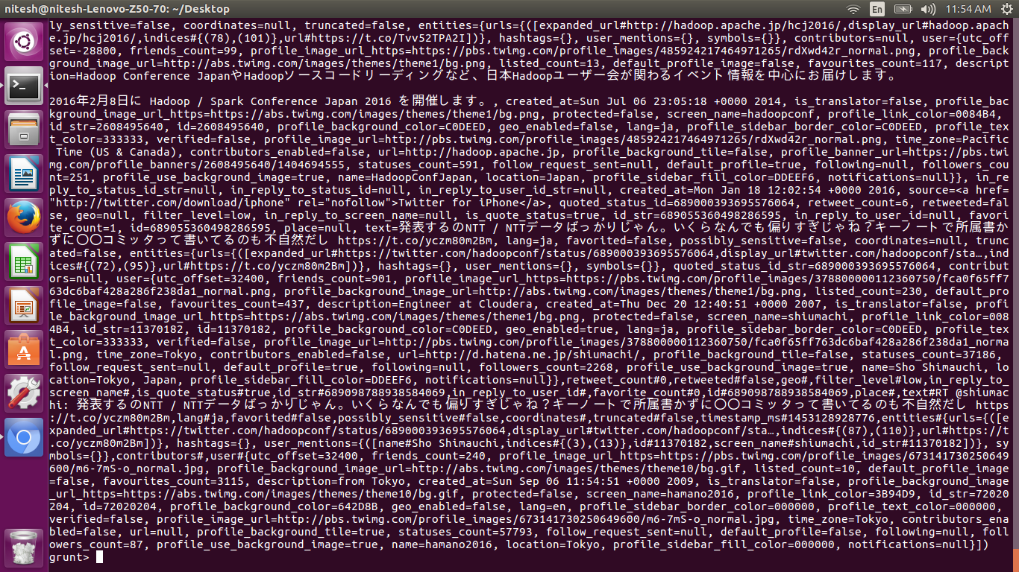

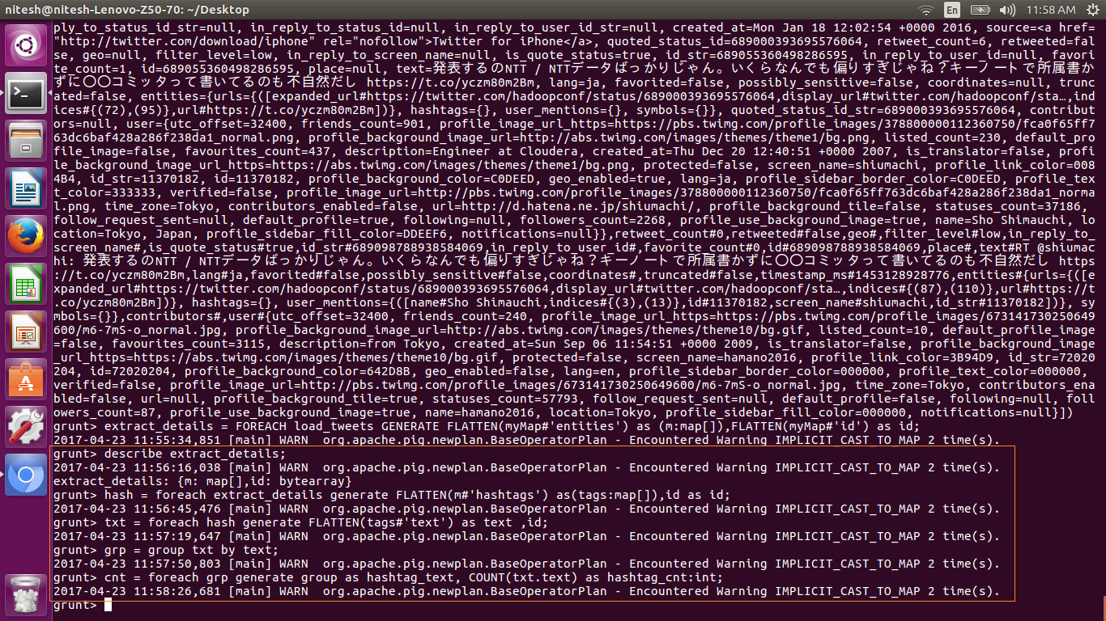

The commands shown in the above screen shots are used to get the count of the hashtags. And after dumping cnt we get the required count of the hashtags.

